# FWD_Advanced Embedded Diploma

**Automotive Door Control System Design**

**By Mohamed Samy**

**Table Content**

**1. Block Diagram (Req. 1) 1**

**2. Static Design (Req. 2) 2**

2.1. Layered Architecture (ECU1) 2

2.1.1. On Board Components: 2

2.1.2. Modules: 2

2.1.3. Folder structure: 3

2.1.4. Typedefs and Enmus used: 4

2.1.5. APIs and Private functions: 5

2.2. Layered Architecture (ECU2) 11

2.2.1. On Board Components: 11

2.2.2. Modules: 11

2.2.3. Folder structure: 12

2.2.4. Typedefs and Enmus used: 13

2.2.5. APIs and Private functions: 14

**3. Dynamic Design (Req. 3) 19**

3.1. On Board Components State Machine (ECU1) 19

3.2. ECU State Machine (ECU1): 20

3.3. ECU Sequence Diagram (ECU1): 21

3.4. CPU Load (ECU1): 21

3.5. On Board Components State Machine (ECU2) 22

3.6. ECU State Machine (ECU2): 23

3.7. ECU Sequence Diagram (ECU2): 24

3.8. CPU Load (ECU2): 24

**4. CAN Bus Load (Req. 3) 25**

# Block Diagram (Req. 1)

System block diagram that show all system blocks and design constraints

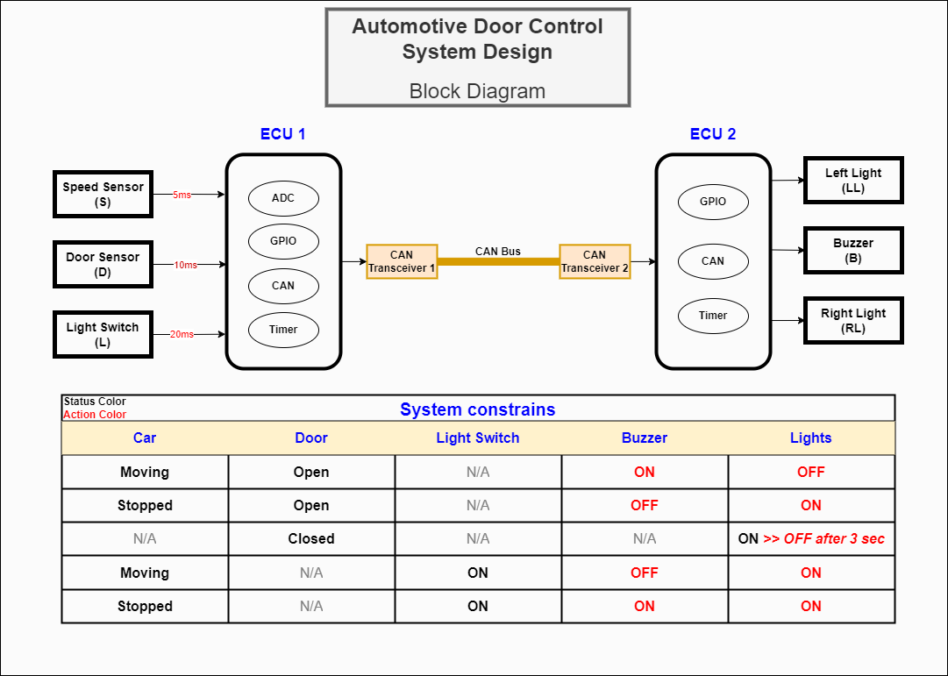

# Static Design (Req. 2)

## Layered Architecture (ECU1)ECU1 Layered Architecture

### On Board Components:

* Door Sensor (Digital)
* Speed Sensor (Analog)
* Light Switch (Digital)

### Modules:

* Timer Module
* GPIO Module
* CAN Module
* ADC Module
* Door Module
* Speed Module
* Switch Module
* Application Module

### Folder structure:

| **Application Folder** | **main.c** | |
| --- | --- | --- |
| **app.h** | |
| **app.c** | |
| **Service Folder** | **OS_config.h** | |
| **OS_interface.h** | |
| **OS.c** | |
| **OnBoard Folder** | DoorSensor Folder | **DoorSensor_confg.h** |
| **DoorSensor_interface.h** |
| **DoorSensor.c** |
| SpeedSensor Folder | **SpeedSensor_confg.h** |
| **SpeedSensor_interface.h** |
| **SpeedSensor.c** |
| LightSwitch Folder | **LightSwitch _confg.h** |
| **LightSwitch _interface.h** |
| **LightSwitch.c** |
| **MCAL Folder** | Timer | **Timer_confg.h** |
| **Timer_interface.h** |
| **Timer.c** |
| GPIO | **GPIO_confg.h** |
| **GPIO_interface.h** |
| **GPIO.c** |
| CAN | **CAN_confg.h** |
| **CAN_interface.h** |
| **CAN.c** |
| ADC | **ADC_confg.h** |
| **ADC_interface.h** |
| **ADC.c** |
| **Common** | **STD_Types.h** | |
| **Bit_Math.h** | |

### Typedefs and Enmus used:

| ***DataType*** | ***Description*** |
| --- | --- |
| Enum RetState_t | Used to return all function execution status |
| struct TimerConfig_st | Used to hold timer configurations |
| struct GPIOConfig_st | Used to hold GPIO configurations |
| Enum GPIO_Pin_t | GPIO pins names |
| Enum GPIO_Port_t | GPIO ports names |
| Enum GPIO_PinState_t | GPIO digital read states |
| struct CANConfig_st | Used to hold CAN configurations |
| Enum CAN_NodeID_t | CAN bus nodes available to be selected |
| Enum CAN_MsgSize_t | Data size available to be selected for CAN message |
| struct ADCConfig_st | Used to hold ADC configurations |
| Enum ADC_Channel_t | Available channels of ADC |
| Enum Doors_t | Car doors to be selected later (4 doors, 2 doors) |
| struct Door_st {Doors_t, GPIOConfig_st} | Used as object of door that holds all its data |
| Enum SpeedSensors_t | Car speed sensors to be selected |
| struct SpeedSensor_st{SpeedSensors_t, ADCConfig_st} | Used as object of speed sensors that holds all its data |
| Enum Switchs_t | Car switches to be selected |
| struct Switch_st{Switchs_t, GPIOConfig_st} | Used as object of switches that holds all its data |
| EventFlag_ECU1 | Event flag group that stores sensors values ***(OS feature)*** |

### APIs and Private functions:

| **Timer Module** | |
| --- | --- |
| APIs | |
| RetState_t Timer_init(void) | |
| Layer | MCAL |
| Input parameters | (void) Utilise configuration array of the module |
| Return value | RetState_t |
| Description | Used to initiate timer peripherals with the required setting stated by user in the configuration array |
| RetState_t Timer_start(void) | |
| Layer | MCAL |
| Input parameters | (void) |
| Return value | RetState_t |
| Description | Used to start timer counting and trigger an interrupt for each tick in the timer. |
| RetState_t callBack_register(<parameter>) | |
| Layer | MCAL |
| Input parameters | (*void ptrToCBFunction) |
| Return value | RetState_t |
| Description | Used by upper layers to set the ISR action of timer interrupt. |

| **GPIO Module** | |
| --- | --- |
| APIs | |
| RetState_t GPIO_init(void) | |
| Layer | MCAL |
| Input parameters | (void) Utilise configuration array of the module |
| Return value | RetState_t |
| Description | Used to initiate GPIO pins according to GPIO configuration array |
| RetState_t GPIO_ConfigPin(<parameters>) | |
| Layer | MCAL |
| Input parameters | (GPIOConfig_st Config) |
| Return value | RetState_t |
| Description | Used to configure specific pin not mentioned in the configuration array |
| RetState_t GPIO_GetPin(<parameters>) | |
| Layer | MCAL |
| Input parameters | (GPIO_Pin_t Pinx,  GPIO_Port_t Portx  GPIO_PinState_t* PinReading) |
| Return value | RetState_t |
| Description | Used to get specific GPIO pin |
| RetState_t GPIO_SetPin(<parameters>) | |
| Layer | MCAL |
| Input parameters | (GPIO_Pin_t Pinx,  GPIO_Port_t Portx) |
| Return value | RetState_t |
| Description | Used to set specific GPIO pin |

| **CAN Module** | |
| --- | --- |
| APIs | |
| RetState_t CAN_init(void) | |
| Layer | MCAL |
| Input parameters | (void) Utilise configuration array of the module |
| Return value | RetState_t |
| Description | Used to initiate CAN peripheral according to CAN configuration array |
| RetState_t CAN_SendMessage(<parameters>) | |
| Layer | MCAL |
| Input parameters | (CAN_NodeID_t NodeID,  uint8_t* MsgBuffer,  CAN_MsgSize_t MsgSize) |
| Return value | RetState_t |
| Description | Used to send specific message to specific node on the CAN bus |

| **ADC Module** | |
| --- | --- |
| APIs | |
| RetState_t ADC_init(void) | |
| Layer | MCAL |
| Input parameters | (void) Utilise configuration array of the module |
| Return value | RetState_t |
| Description | Used to initiate ADC peripheral according to ADC configuration array |
| RetState_t ADC_ConfigChannel(<parameters>) | |
| Layer | MCAL |
| Input parameters | (ADCConfig_st) |
| Return value | RetState_t |
| Description | Used to initiate ADC peripheral according to ADC configuration array |
| RetState_t ADC_GetAnalogRead(<parameters>) | |
| Layer | MCAL |
| Input parameters | (ADC_Channel_t Channel,  float* SensorAnalogRead) |
| Return value | RetState_t |
| Description | Used to get the analog read of a sensor connected to a specific channel pre-defined by the user.  Value is evaluated inside this API using ADC_GetDigtalRead private function to get current digital reading then map it according to the connected sensor configurations in the module. |
| Private Functions | |
| RetState_t ADC_GetDigtalRead(<parameters>) | |
| Layer | MCAL |
| Input parameters | (ADC_Channel_t Channel,  uint16_t* DigReading) |
| Return value | RetState_t |
| Description | Used internally in the ADC_GetAnalogRead() to evaluate the current digital value. |

| **Door Module** | |
| --- | --- |
| APIs | |
| RetState_t DoorSensor_init(<parameters>) | |
| Layer | OBAL |
| Input parameters | (Door_st* SelectedDoorPtr) |
| Return value | RetState_t |
| Description | Used to initiate door sensor pin according to input structure stores pin used with the sensor and its configurations |
| RetState_t DoorSensor_GetRead(<parameters>) | |
| Layer | OBAL |
| Input parameters | (Door_st* SelectedDoorPtr,  uint_t* DoorSensorReading) |
| Return value | RetState_t |
| Description | Used to get specific GPIO pin |

| **Speed Module** | |
| --- | --- |
| APIs | |
| RetState_t SpeedSensor_init(<parameters>) | |
| Layer | OBAL |
| Input parameters | (SpeedSensor_st* SelectedSensorPtr) |
| Return value | RetState_t |
| Description | Used to initiate a speed sensor according to the sensor object (structure) configurations. |
| RetState_t SpeedSensor_GetRead(<parameters>) | |
| Layer | OBAL |
| Input parameters | (SpeedSensor_st* SelectedSensorPtr,  float* DoorSensorReading) |
| Return value | RetState_t |
| Description | Used to get specific sensor current speed |

| **Switch Module** | |
| --- | --- |
| APIs | |
| RetState_t Switch_init(<parameters>) | |
| Layer | OBAL |
| Input parameters | (Switch_st* Switch) |
| Return value | RetState_t |
| Description | Used to initiate a switch. |
| RetState_t Switch_GetRead(<parameters>) | |
| Layer | OBAL |
| Input parameters | (Switch_st* Switch,  uint8_t* DoorSensorReading) |
| Return value | RetState_t |
| Description | Used to get current reading of the switch button. |

| **BCM Manager Module** | |
| --- | --- |
| APIs | |
| RetState_t BCM_Manager(void) | |
| Layer | OS Layer |
| Input parameters | (void) Utilise event flag as input |
| Return value | RetState_t |
| Description | Send Fetched sensors reading from EventFlag_ECU1 and send them over communication bus |

| **Application Module** | |
| --- | --- |
| APIs | |
| RetState_t HW_init(void) | |
| Layer | Application Layer |
| Input parameters | (void) |
| Return value | RetState_t |
| Description | Initiate system setting according to lower layers configurations. |
| RetState_t SendSpeed(void) | |
| Layer | Application Layer |
| Input parameters | (void) |
| Return value | RetState_t |
| Description | Send car speed every 5ms utilising timer tick |
| RetState_t SendDoorState(void) | |
| Layer | Application Layer |
| Input parameters | (void) |
| Return value | RetState_t |
| Description | Send door state every 10ms utilising timer tick |
| RetState_t SendSwitchState(void) | |
| Layer | Application Layer |
| Input parameters | (void) |
| Return value | RetState_t |
| Description | Send Switch state every 20ms utilising timer tick |

## **Layered Architecture (ECU2)**

### On Board Components:ECU1 Layered Architecture

* Buzzer (Digital)
* Lights (Digital)

### Modules:

* Timer Module
* GPIO Module
* CAN Module
* Buzzer Module
* Lights Module
* Application Module

### Folder structure:

| **Application Folder** | **main.c** | |
| --- | --- | --- |
| **app.h** | |
| **app.c** | |
| **Service Folder** | **OS_config.h** | |
| **OS_interface.h** | |
| **OS.c** | |
| **OnBoard Folder** | Buzzer Folder | **Buzzer_confg.h** |
| **Buzzer_interface.h** |
| **Buzzer.c** |
| Light Folder | **Light_confg.h** |
| **Light_interface.h** |
| **Light.c** |
| **MCAL Folder** | Timer | **Timer_confg.h** |
| **Timer_interface.h** |
| **Timer.c** |
| GPIO | **GPIO_confg.h** |
| **GPIO_interface.h** |
| **GPIO.c** |
| ADC | **ADC_confg.h** |
| **ADC_interface.h** |
| **ADC.c** |
| **Common** | **STD_Types.h** | |
| **Bit_Math.h** | |

### 

### Typedefs and Enmus used:

| ***DataType*** | ***Description*** |
| --- | --- |
| Enum RetState_t | Used to return all function execution status |
| struct TimerConfig_st | Used to hold timer configurations |
| struct GPIOConfig_st | Used to hold GPIO configurations |
| Enum GPIO_Pin_t | GPIO pins names |
| Enum GPIO_Port_t | GPIO ports names |
| Enum GPIO_PinState_t | GPIO digital read states |
| struct CANConfig_st | Used to hold CAN configurations |
| Enum CAN_MsgSize_t | Data size available to be selected for CAN message |
| Enum Buzzer_t | Enum used to select which buzzer to operate |
| struct Buzzer_st {Buzzer_t, GPIOConfig_st} | Used as object of Buzzer that holds all its data |
| Enum Light_t | Enum used to select which Light to operate |
| struct Light_st{Light_t, GPIOConfig_st} | Used as object of Light that holds all its data |
| Enum App_Device_t | Enum used to define application used devices (Buzzer , LeftLight, Right Light) |
| EventFlag_ECU2 | Event flag group that stores sensors values ***(OS feature)*** |

### APIs and Private functions:

| **Timer Module** | |
| --- | --- |
| APIs | |
| RetState_t Timer_init(void) | |
| Layer | MCAL |
| Input parameters | (void) Utilise configuration array of the module |
| Return value | RetState_t |
| Description | Used to initiate timer peripherals with the required setting stated by user in the configuration array |
| RetState_t Timer_start(void) | |
| Layer | MCAL |
| Input parameters | (void) |
| Return value | RetState_t |
| Description | Used to start timer counting and trigger an interrupt for each tick in the timer. |
| RetState_t callBack_register(<parameter>) | |
| Layer | MCAL |
| Input parameters | (*void ptrToCBFunction) |
| Return value | RetState_t |
| Description | Used by upper layers to set the ISR action of timer interrupt. |

| **GPIO Module** | |
| --- | --- |
| APIs | |
| RetState_t GPIO_init(void) | |
| Layer | MCAL |
| Input parameters | (void) Utilise configuration array of the module |
| Return value | RetState_t |
| Description | Used to initiate GPIO pins according to GPIO configuration array |
| RetState_t GPIO_ConfigPin(<parameters>) | |
| Layer | MCAL |
| Input parameters | (GPIOConfig_st Config) |
| Return value | RetState_t |
| Description | Used to configure specific pin not mentioned in the configuration array |
| RetState_t GPIO_GetPin(<parameters>) | |
| Layer | MCAL |
| Input parameters | (GPIO_Pin_t Pinx,  GPIO_Port_t Portx  GPIO_PinState_t* PinReading) |
| Return value | RetState_t |
| Description | Used to get specific GPIO pin |
| RetState_t GPIO_SetPin(<parameters>) | |
| Layer | MCAL |
| Input parameters | (GPIO_Pin_t Pinx,  GPIO_Port_t Portx) |
| Return value | RetState_t |
| Description | Used to set specific GPIO pin |

| **CAN Module** | |
| --- | --- |
| APIs | |
| RetState_t CAN_init(void) | |
| Layer | MCAL |
| Input parameters | (void) Utilise configuration array of the module |
| Return value | RetState_t |
| Description | Used to initiate CAN peripheral according to CAN configuration array |
| RetState_t CAN_ReadBus(<parameters>) | |
| Layer | MCAL |
| Input parameters | (uint8_t* MsgBuffer,  CAN_MsgSize_t MsgSize) |
| Return value | RetState_t |
| Description | Used to read CAN bus (Transceiver buffer). |

| **Buzzer Module** | |
| --- | --- |
| APIs | |
| RetState_t Buzzer_init(<parameters>) | |
| Layer | OBAL |
| Input parameters | (Buzzer_st* SelectedBuzzerPtr) |
| Return value | RetState_t |
| Description | Used to initiate Buzzer pin according to input structure. |
| RetState_t Buzzer_Set(<parameters>) | |
| Layer | OBAL |
| Input parameters | (Buzzer_st* SelectedBuzzerPtr,  GPIO_PinState_t BuzzerState) |
| Return value | RetState_t |
| Description | Used to turn buzzer on/off |

| **Light Module** | |
| --- | --- |
| APIs | |
| RetState_t Light_init(<parameters>) | |
| Layer | OBAL |
| Input parameters | (Light_st* SelectedSensorPtr) |
| Return value | RetState_t |
| Description | Used to initiate light pins according to input structure. |
| RetState_t Light_Set(<parameters>) | |
| Layer | OBAL |
| Input parameters | (Light_st* SelectedLightPtr,  GPIO_PinState_t LightState) |
| Return value | RetState_t |
| Description | Used to turn Lights on/off |

| **BCM Manager Module** | |
| --- | --- |
| APIs | |
| RetState_t BCM_Manager(void) | |
| Layer | OS Layer |
| Input parameters | (void) Utilise event flag as input |
| Return value | RetState_t |
| Description | Read sensors states over communication bus and store them inside EventFlag_ECU2 |

| **Application Module** | |
| --- | --- |
| APIs | |
| RetState_t HW_init(void) | |
| Layer | Application Layer |
| Input parameters | (void) |
| Return value | RetState_t |
| Description | Initiate system setting according to lower layers configurations. |
| RetState_t OperateDigDev(<parameters>) | |
| Layer | Application Layer |
| Input parameters | (App_Device_t SelectedDevice,  GPIO_PinState_t State_t) |
| Return value | RetState_t |
| Description | Implement logic to operate devices according to system constraints.  Used to operate a specific device (Light, Buzzer.  Operation based on data pushed from GetSensorsValues. |

# Dynamic Design (Req. 3)

## On Board Components State Machine (ECU1)

* + 1. Speed Sensor Component:

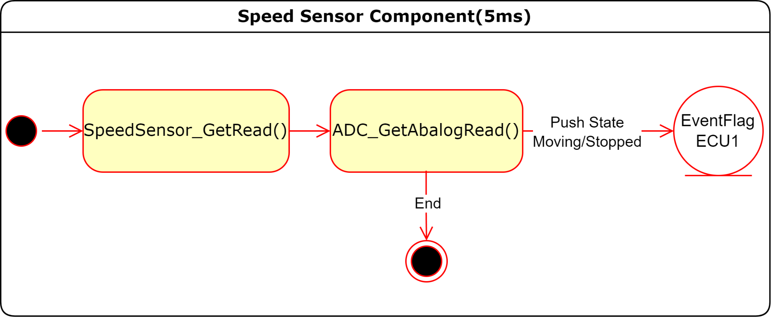

* + 1. Door Sensor Component:

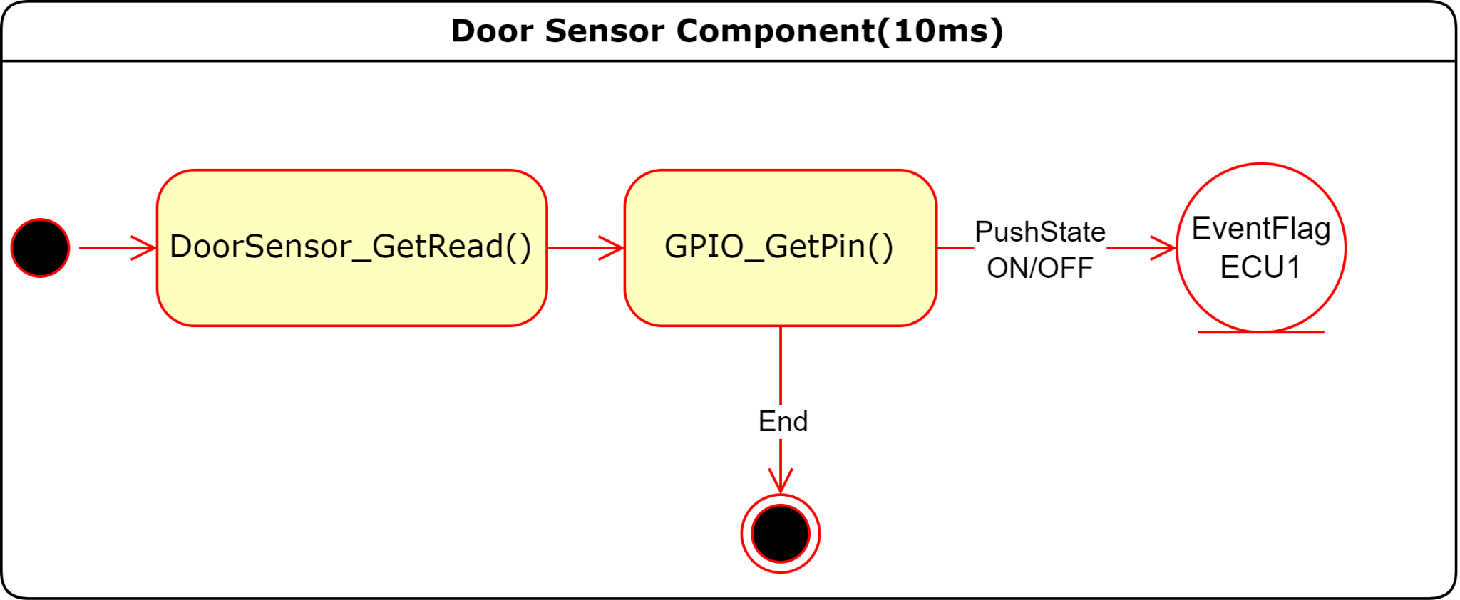

* + 1. Switch Component:

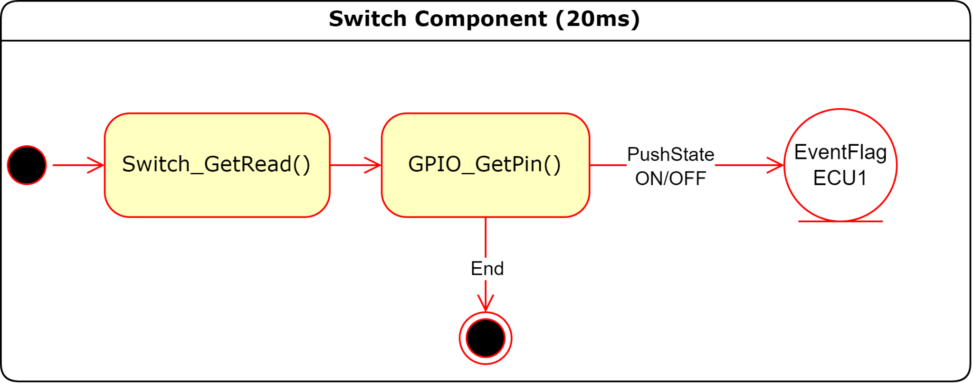

## ECU State Machine (ECU1):

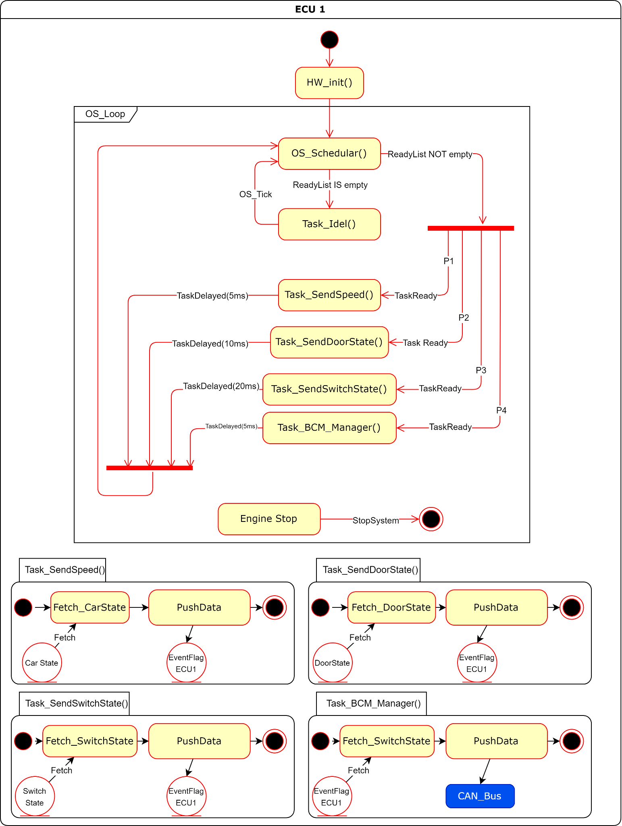

## ECU Sequence Diagram (ECU1):

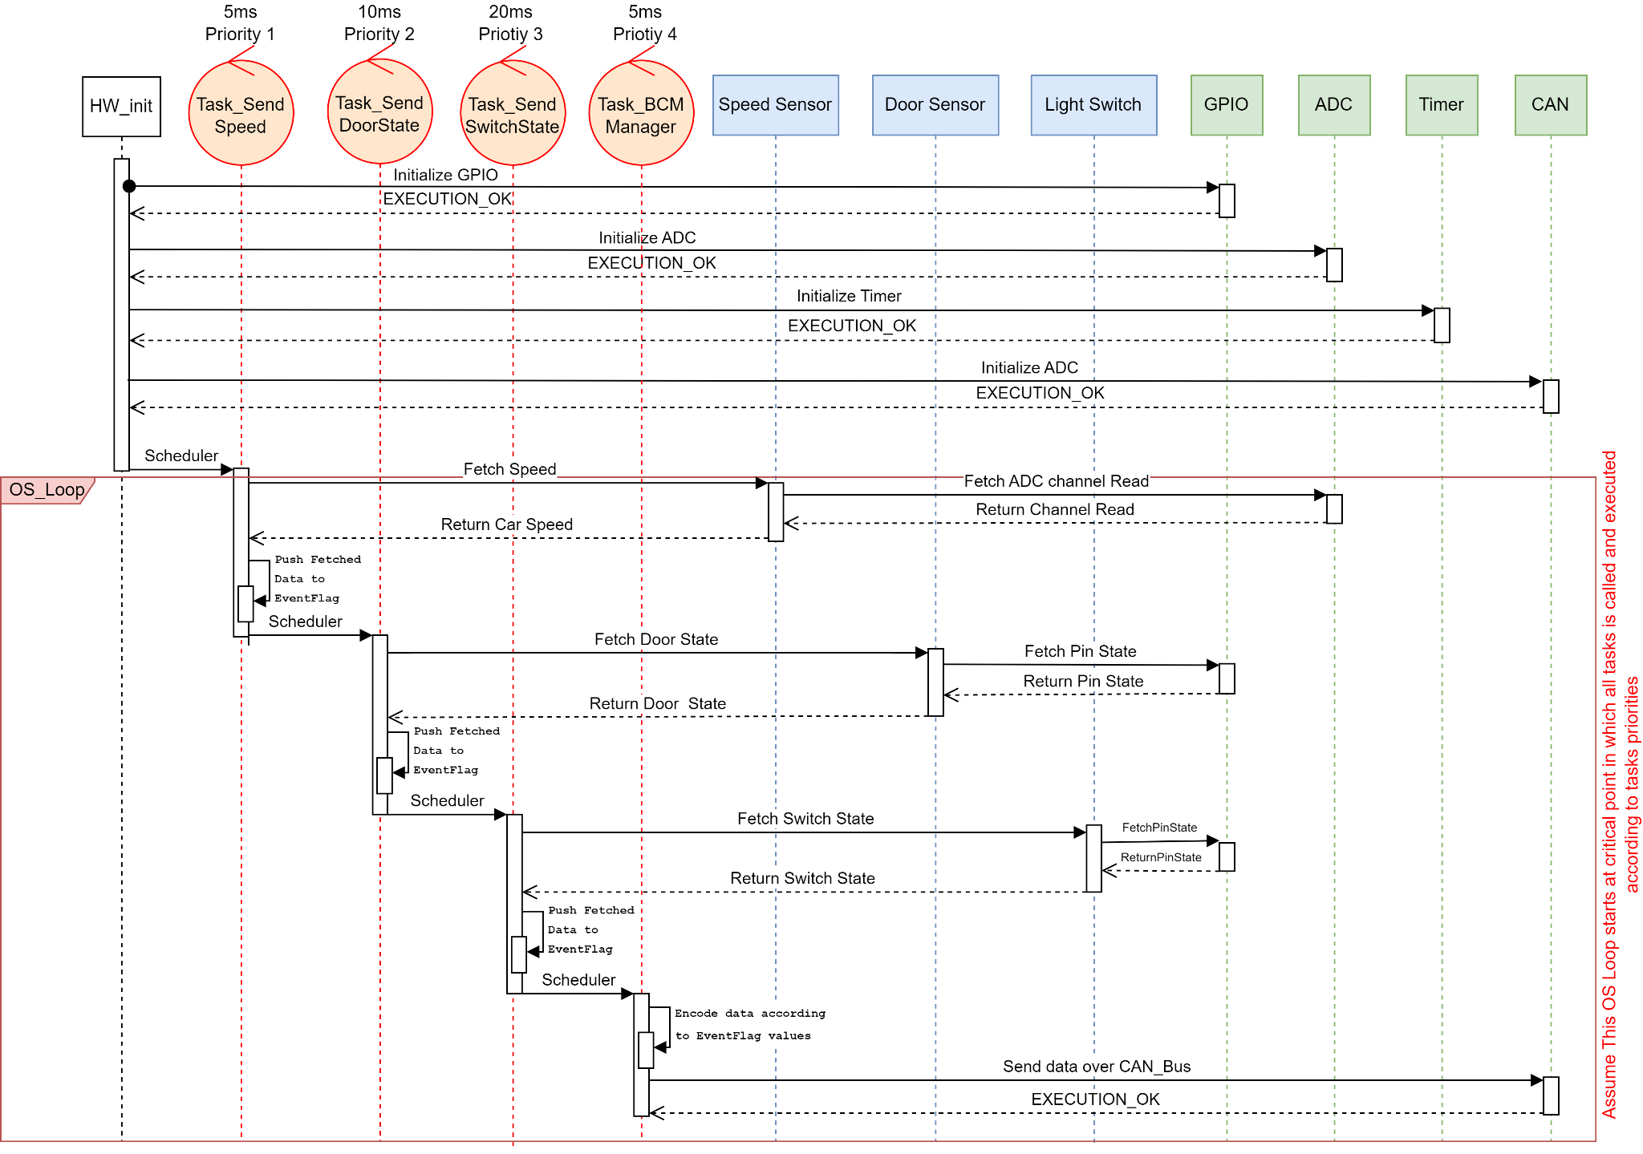

## CPU Load (ECU1):

Assume:-

## On Board Components State Machine (ECU2)

* + 1. Buzzer Component:

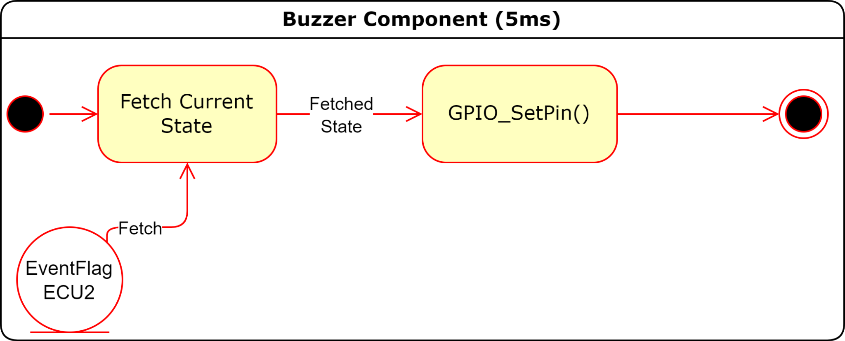

* + 1. Lights Component:

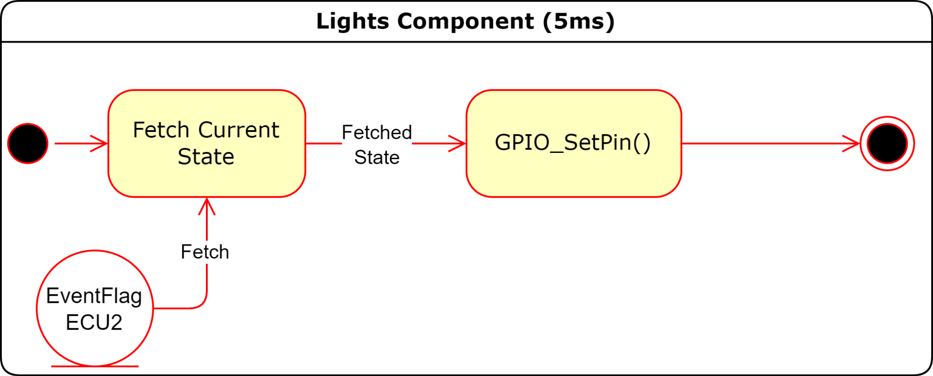

## ECU State Machine (ECU2):

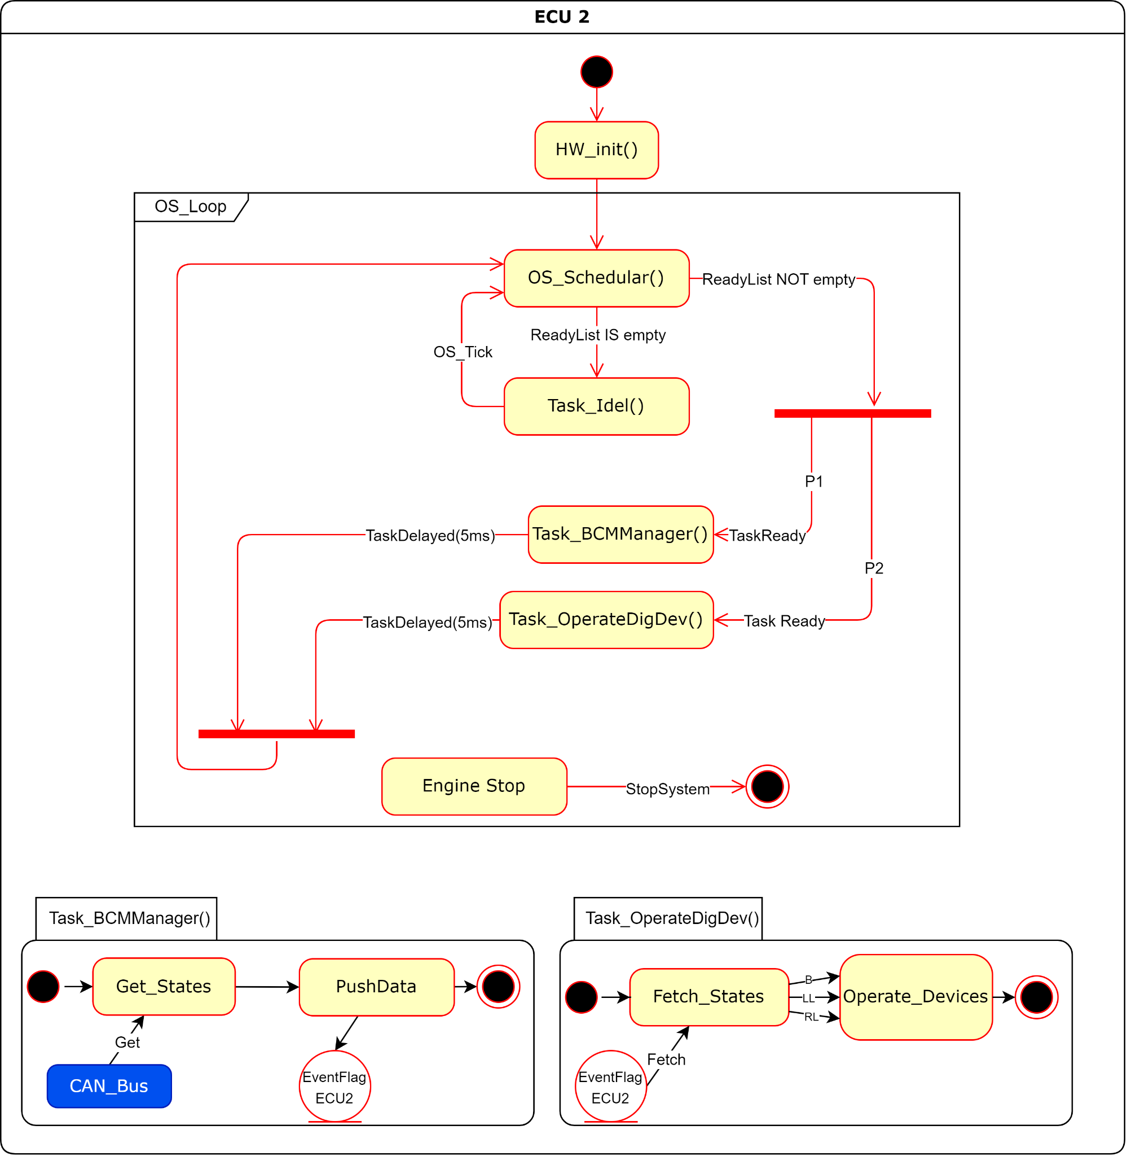

## ECU Sequence Diagram (ECU2):

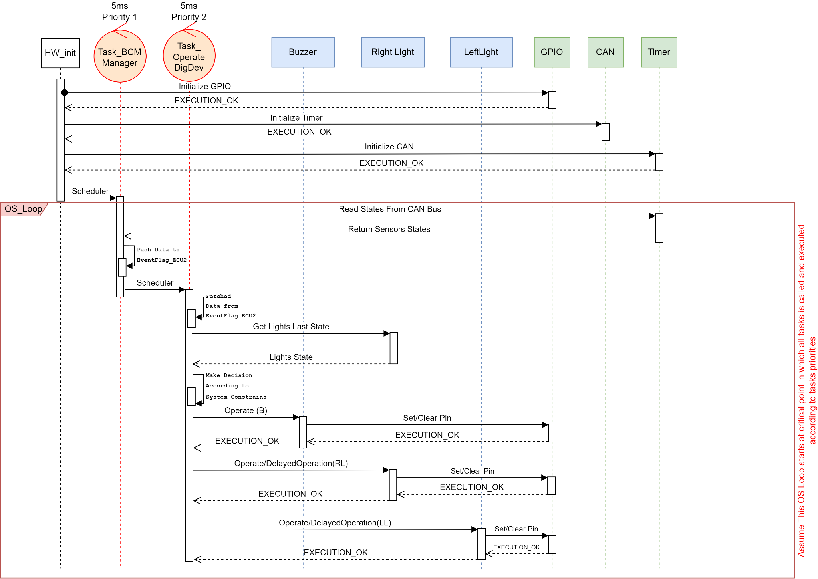

## CPU Load (ECU2):

Assume:-

# CAN Bus Load (Req. 3)

* ***CAN Bus Configurations:***

Assume using CAN_LowSpeed at rate of (125 kbit/second)

Assume each sensor state is encoded in 1-bit

| Car Moving State | 0 -> Stopped | 1 -> Moving |
| --- | --- | --- |
| Door Sensor State | 0 -> Closed | 1 -> Opened |
| Light Switch Sensor State | 0 -> OFF | 1 -> ON |

So we have 3-bits of data ***rounded up to 1-Byte***

* ***CAN Frame size calculations:***

* ***CAN Frame Speed calculations:***

So it takes 0.408 ms to send one frame

* ***CAN Bus Load calculations:***

Knowing that (BCM_Manager) in ECU1 is sending one frame periodically each 5ms

**Answer = 8.16 %**